**Python Lab – 3**

**Total Marks: 5**

Use the given graph and perform the following tasks in Python:

* Store the graph using appropriate data structure
* Answer the following questions:
  + List the degree of each node
  + Input any 2 nodes and find if there exists a path between them.
  + Closeness for any node x is defined as C(x) = $N/{\sum_{y}{d(y,x)}}$, where N is the number of nodes and d(y,x) is the distance between y and x.
  + Can you plot the graph and display it on screen? (2 marks extra)

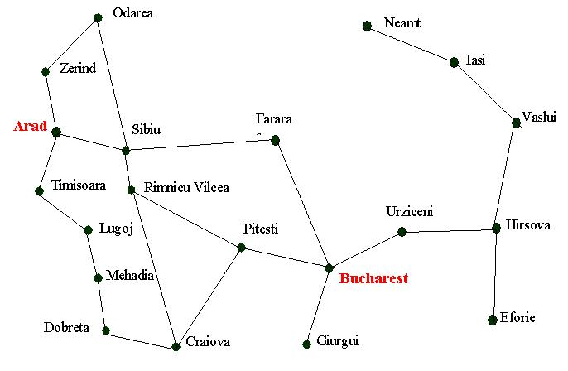One of the locations you may refer to for help while working with graphs:

<http://www.python-course.eu/graphs_python.php>